**ASSIGNMENT-1**

Create a blog or website using Blogspot and WordPress .Customize the theme design and post new article with 500 words.

|  |  |
| --- | --- |
| NAME | Deepak.R |
| NM ID | 9DFDF985C4FC711933E4B6077834F86E |
| ASSIGNMENT 1 | Create a blog or website using Blogspot and WordPress |

**Blog page link:**

https://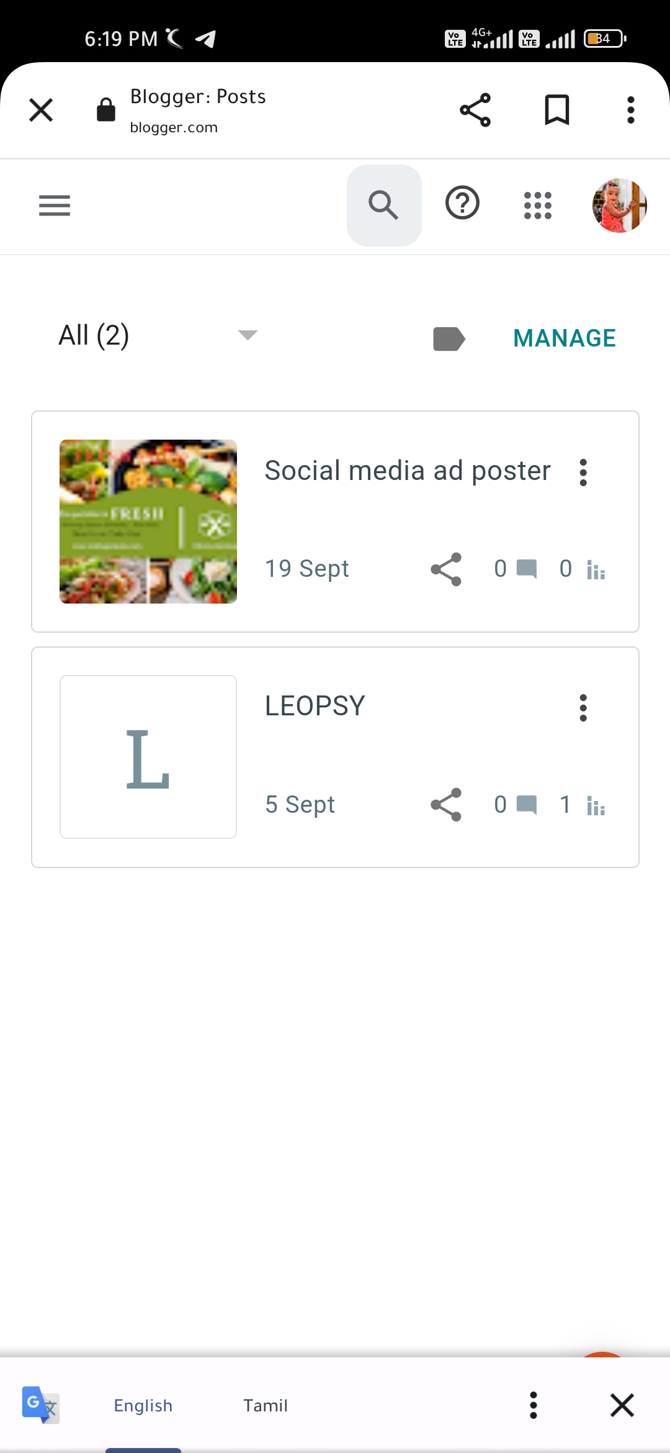www.blogger.com/blog/posts/8993326665400245507